Lab Experiment: Basic Image Handling and Processing Operations
Experiment No: 3
Aim
To read an image using Python and detect its outlines (edges) using the Canny Edge Detection function in the OpenCV library.
Tools Required
- Python 3.x
- OpenCV (cv2)
- NumPy
- VS Code / PyCharm / Jupyter Notebook
- Input Image
Procedure
- Install the OpenCV library using:
- Import the OpenCV library.
- Read the input image using cv2.imread().
- Convert the image to grayscale.
- Apply the Canny edge detection function using cv2.Canny().
- Display the original image and the detected edges.
- Wait for a key press and close all image windows.
Code
import cv2
# Step 1: Read the image
img = cv2.imread("sample.jpeg")
# Check if image is loaded
if img is None:
print("Error: Image not found")
else:
# Step 2: Convert to Gray (required for Canny)
gray = cv2.cvtColor(img, cv2.COLOR_BGR2GRAY)
# Step 3: Apply Canny Edge Detection
edges = cv2.Canny(gray, 100, 200)

# Step 4: Save the output image
cv2.imwrite("canny_edges.jpg", edges)

# Step 5: Display images
cv2.imshow("Original Image", img)
cv2.imshow("Canny Edge Image", edges)

cv2.waitKey(0)
cv2.destroyAllWindows()
Output
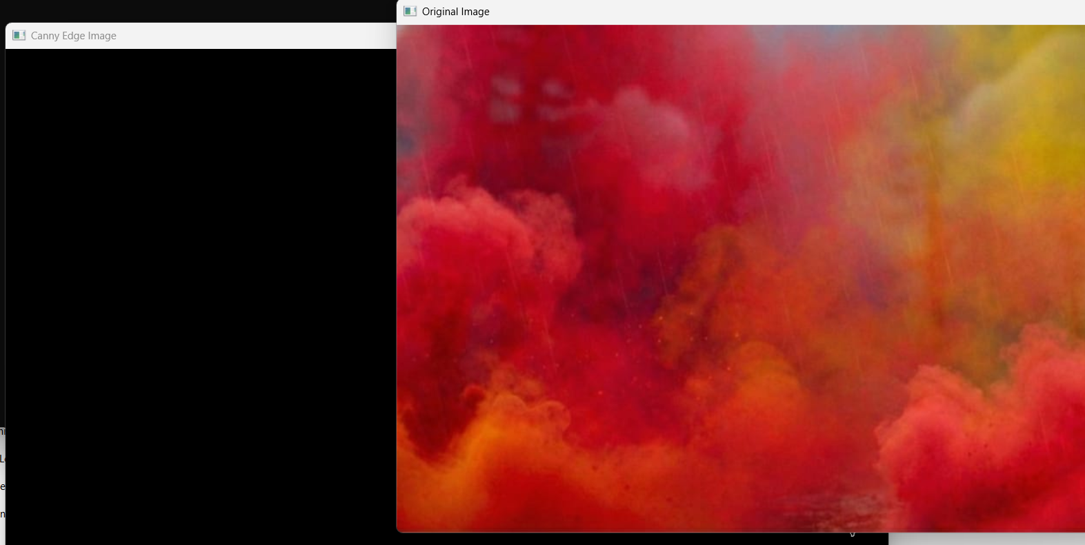
Result
The input image was successfully read using Python, and the Canny Edge Detection function was applied to detect the outlines of objects. The edge-detected image was displayed successfully.

